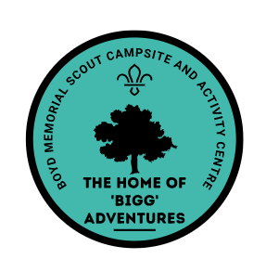


Climbing Harness Declaration Form
In accordance with the Boyd Climbing Tower – Operation Risk Assessment, I declare that I am competent to supervise on the Climbing Tower on Boyd Scout Campsite.
Where climbing harnesses not belonging to Boyd Scout Campsite are to be used on site, I declare that these harnesses are fit for use and have been inspected prior to use. In addition, I accept any and all liability resulting from the use of my / our own harnesses and I understand that I must adhere to the Boyd Climbing Tower Risk Assessments at all times.
Note – Only harnesses for leaders can this declaration be applied. For all your people, only harnesses provided by Boyd Activity Centre be used.
Harness Reference | Checked Prior to Use

Signed -

Signed by Boyd Site Crewmember -

Date -

