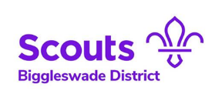

Water Activity Disclaimer for the use of Personal Craft on Boyd Scout Campsite

In accordance with the Boyd Kayak – Canoe Risk Assessment I declare that I am competent to operate Kayaks / Canoes on the Class C water on Boyd Scout Campsite.

Where craft not belonging to Boyd Scout Campsite is to be used on site, I declare that these craft are fit for use and have been inspected prior to use. In addition, I accept any and all liability for damage to said craft, and I understand that I must adhere to the Boyd Kayak – Canoe Risk Assessment at all times.
Craft Reference | Checked Prior to Use | Signature

Signed -

Date -

